**Task 1**

1. Red hat , ubuntu , debian
2. It provides short reference manuals to commands, API functions , concepts and configuration file syntax.
3. rm: remove files not directories , rmdir: remove only empty directories
4. a- it failed to remove it as directory is not empty so we delete file1 first to delete dir11

b- the hierarchy got destroyed as -p deletes the directory and its parent

c- absolute path: /home/docs , relative path: docs/

5 ,6 - 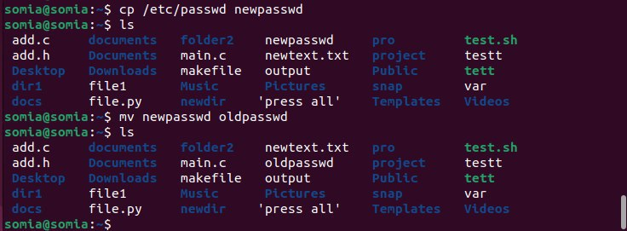

7- cd ../../home

cd /home

8- 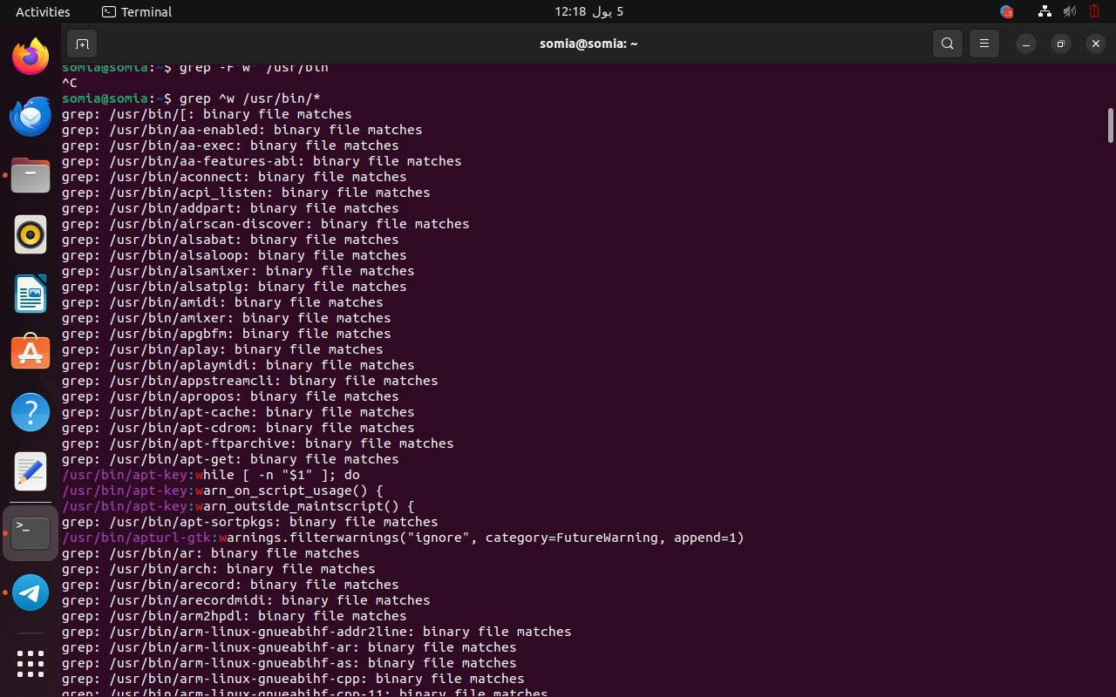

9- type command shows which category the command belongs to

10- 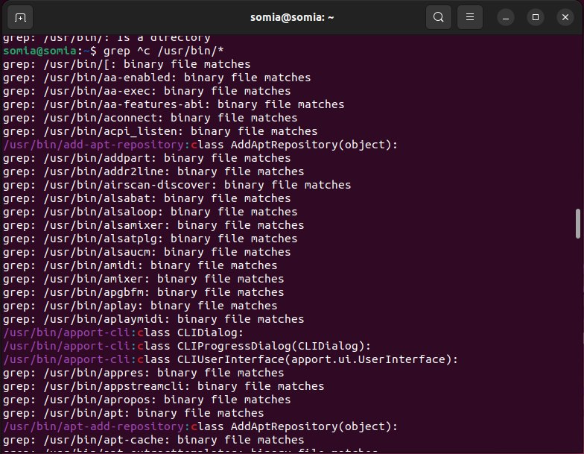

11- man read

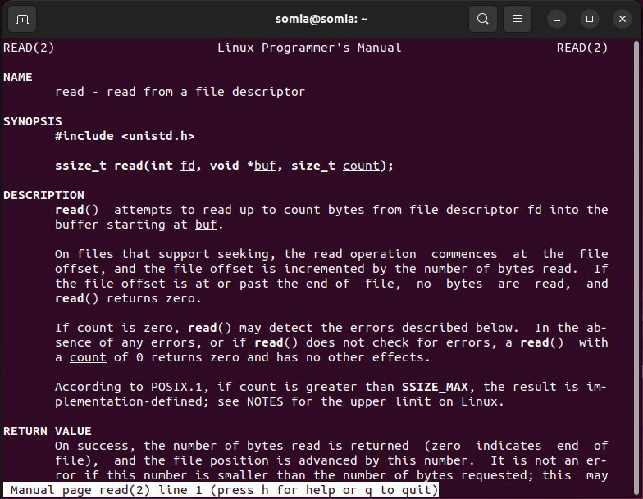

12- search the manual page names and descriptions